1. Chrome

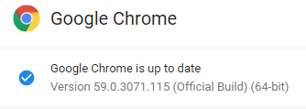

1. Slack

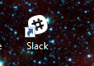

1. Sublime Text

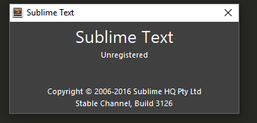

1. GitBash

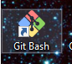

1. Heroku toolbelt– Yes
2. Node.js - Yes
3. MYsql

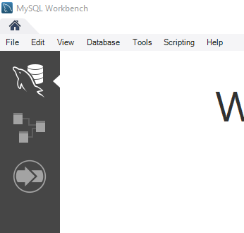

1. MAMP – yes
2. SSH Key – yes